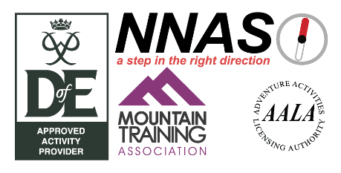

DofE Program Planner

Name:

Physical

Volunteering

Skill

Activity Chosen (give some details):

Activity Chosen (give some details)

Activity Chosen (give some details):

Where & When (including Start & Finish Date)?

Where & When (including Start & Finish Date)?

What are your goals?

What are your goals?

What are your next steps?

What are your next steps?

What are your goals?

Where & When (including Start & Finish Date)?

What are your next steps?